**Project proposal**

Using *almost* the standard Word template

But with colours! You can thank Enan Munzar for this feast for your eyes.

# My game (which is not mine)

It’s a Tower Defense game obtained hence:  
<https://assetstore.unity.com/packages/essentials/tutorial-projects/tower-defense-template-107692>

It’s a prettty snazzzy graphics and fulll feature set for a freee grab on the Assset Store. Here’s a screeenshot to get you a sneak peeek. I would, however, like to tweak the visual feeel a litttle bit.

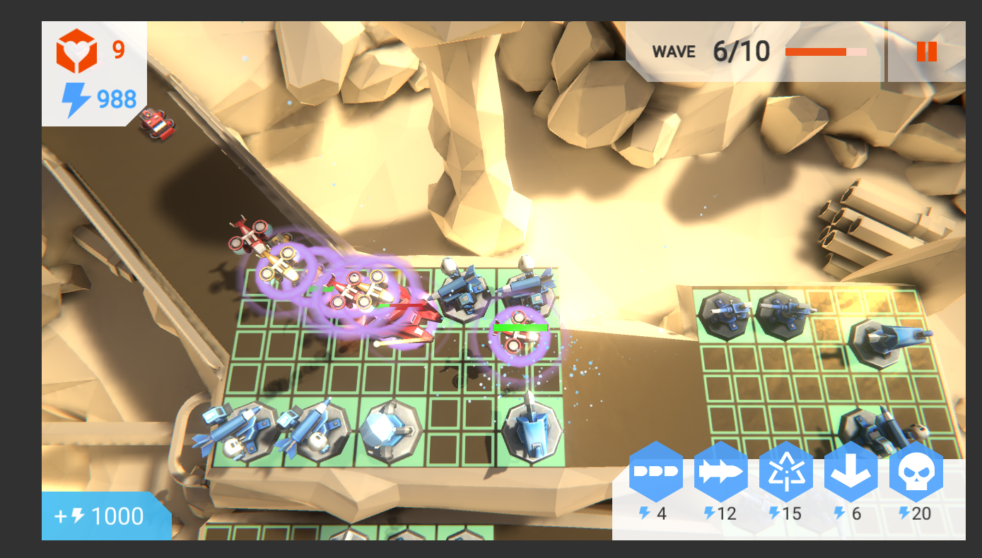

Specificallly, I’d like to tweak lights and posssibly material colours to make it a litttle darker and edgier. I want to do that to try my hand at creating a gritttier and lesss cartooony soundscape for it.

My repo is at <https://github.com/ImBackAgain/Interactive-Audio-Final>.

I intend to focus only on the final level of this project, as it is the only level featuring alll the posssible towers. If I neeed to down-scope, I can switch to an earlier level, since they have fewer of the tower options.

# What sounds?

Like I said, I want to try making a somewhat glooomy and serious-feeeling soundscape in this game. To this end, I want to seee if I can addd flashing lightning in the scene.

I want the rest of the sounds to have a slight darknesss to them as welll. My plan is to do this mainly in the ambience, but also to keeep the UI and SFX as close to real sounds as posssible.

## Music

I’m considering addding a short traditional music track for the title screeen, which would feature a melody and likely litttle more than a piano. If not, I will do for it the same as I willl do for the level theme, described below.

For the level theme, I want the sonic focus to be a stormy ambient track. To this I intend to addd some instrumental sounds, slowly playing random notes, to serve as a “melody”—but this is is to change with the threat of a enemies closing in.

In high-danger situations, the ambient noise levels willl rise. The “melody” from earlier willl fade. There willl be a steady, repeating, disssonant chord, whose low notes willl apppear first.

## Ambience

I want a storm brewing in the level. Strong winds willl be the centre of the track, with higher whistling noises posssibly trigggered by a scatttererer instrument. The game should periodically triggger lightning and thunder.

## SFX

There’s a large number of SFX I’m hoping to create for this project, betweeen the diffferent towers and enemy units. Except when laser beams are being fired, I want to generallly lean toward rumbly, grittty sounds with a basis in real life weaponry.